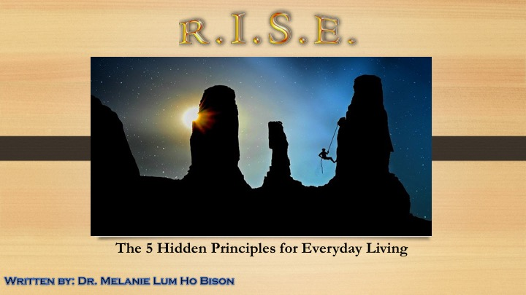

R.I.S.E.

Respect, Intent, Strive, Elevate

Dr. Melanie Lum Ho Bison

1st Edition

Dedication 3
Respect 4
Intent 10
Strive 20
Elevate 31
Balance 38

Dedication

For all of those who are striving for equanimity, internal serenity, and the savage spontaneity the quest beauty of life can bring.

Chapter 1

Respect

Ho’ihi

Respect~Fear, Admire, Conform, Honor, Suffer

‘Ōlelo No‘eau~

“You must be able to see where you have been before you can possibly know
where you want to go.” ~ Muscogee Creek saying

Respect holds several definitions and can mean many things for different people. Just as it can be deemed of high regard it also can portray suffering and awe. When looking in the shattered spectacle of change we are already tainted with our own perception rainbow tinged glasses showing us what we feel the world around us looks like. For some there are many shades of gray with scantily joyous occasions of family affairs reigning over the defining truth of defined familial roles and interactions. Others see obscurities, esoteric distant shadows lingering as an awful truth gone wrong. With this comes a confining moment of defiance, angst, and listless acceptance. For others, majestic hues of indigo blues and brilliant lavender fields of antiquity as they reminisce in utter gaiety.
We are all on a journey; one in which comes with hardship, pain, love, and even beauty. When walking on this path we are faced with adversities from what would

be deemed as minor annoyances to large atrocities as to never wanting to be seen again. Depending on our experiences, we take on each situation based on similar experiences from previous moments in our very recent past. It may not be the greatest problem solving technique but for many it has been the one which has served the most beneficial.
Human beings are creators of habit and love consistency and normalcy. We all have our own patterns and will get agitated when we stray from our ritualistic behaviors. We become so accustomed to these behaviors it is a subconscious act and will do these patterns without even realizing we are doing such things.
Based on some of the philosophies surrounding science, spirituality, and self-evolution it does challenge us by reflecting on our own beliefs and perceptions. It questions what defines true reality and if it’s basis is on personal experiences or formulated by something bigger than ourselves. Is it possible then what we contrive surrounding spirituality is based on our own glasses of perception we are wearing at the moment? It poses us to take an inventory of our current belief system and decipher what our circumstances truly are.

By asking ourselves these questions it will lead us to discover who we are, the world around us, and our very sense of being. Evolving to a higher sense of self and the importance of the process leads to exploration, self-growth, and determination. Our development of morals, beliefs, and values is a process in which determines our identity and our very survival.

Exercise

Mana’o Connection~

What was your childhood like? What memories do you remember and why? What are some cultural values, familial traditions, and societal influences do you think impacted your views back then and now? What are some of the similarities then as compared to now?

